

TERMS & CONDITIONS

for the hire of
ST SAVIOUR’S PARISH CHURCH & HALL

St Saviour’s Parochial Church Council
September 2026

1. AGREEMENT:
These Terms and Conditions of Hire are to be read with and included in the Agreement between the Hirer and the PCC.

2. THE PREMISES:
- The PCC will ensure that the premises are in a fit state for hire.
- The doors of the Church and Hall including all doors constituting emergency escape routes will be unlocked before the event by arrangement, and arrangements will also be made with the hirer for locking the premises.
- It is the responsibility of the hirer to understand the Building and the PCC are covered by the following Licences:
      - Performing Rights Society (PRS)
      - Music Church Licence No. 123052
      - Church Copyright Licence (CCL) No. 1949121 Music Reproduction Licence (MRL) No. 1949138
      - Phonographic Performance Ltd Church Licence (PPL) No. 1949145
      - Premises Licence No. LN/20180077

3. THE HIRE FEE:
- The Hire Fee shall be paid as follows:
- 20% deposit to be paid on booking for Church bookings with remainder payable 28 days prior to the event for Church bookings, unless with prior agreement from Parish Administrator;
- on submission of the Hire Form for Hall bookings.
- The Hall Hire Fee includes the use of all parts of the Hall and general facilities, including the kitchen, cloakroom and toilets during the period of the hire. The Church Hire Fee includes the use of the Church and general facilities, with the hall, cloakroom and hall toilets being available as agreed with the Parish Administrator during the period of the hire.
- In the case of an evening hire of the Hall the Hirer will ensure that activities will end by 10.30pm and the premises vacated by 11.30pm at the latest.

- The Hall Hire Fee includes access to the Hall Kitchen for the purpose of preparing and serving light refreshments only. The preparation of meals and major catering activity may only be carried out with express permission of the Parish Administrator with due regard to requirements for food hygiene law. In the event that a Church Hirer would like Hire of the kitchen, please advise the Parish Administrator who will be able to confirm.
- The Hall Hire will be subject to a deposit advised at the time of booking, which will be released to you within ten working days of the end of the Hire, subject to meeting the Terms and Conditions of the Hire.
- The Hire Fee shall not normally be refunded in the event of cancellation of the event by the Hirer unless the PCC is able to re-hire the Church or Hall at the same rate as the hire fee.
- Where the event is cancelled because the PCC is unable for any reason to provide the use of the Church or Hall to the Hirer unless prevented from doing so by circumstances beyond their control then the PCC shall refund the Hire Fee and this will be the limit of liability of the PCC to the Hirer.

4. RESPONSIBILITY FOR SAFETY:
- The Hirer shall be responsible for ensuring the safety of the event.
- The Hirer or some person designated by the Hirer shall be appointed as the Responsible Person for the event to undertake the overseeing of safety and to ensure that in the event of an emergency the Church and Hall will be efficiently and safely evacuated and the emergency services are summoned. The Responsible Person must provide their contact details and if they change must be advised to the Parish Administrator in writing. If the Responsible Person is also a keyholder their details will be recorded in the parish keyholders’ list until the key is returned.
- The Responsible Person must make himself or herself familiar with the
layout of the Church and the Hall and in particular fire escape routes from the buildings and the locations of fire extinguishers and other fire-fighting equipment as indicated in Annex 1.
- The Responsible Person should ensure that if the event requires significant car parking then Stewards are appointed to ensure that parking is orderly and safe (as set out below).
- The Responsible Person must ensure that all doors on an escape route are not locked or obstructed and can be used should evacuation of the building be necessary.
- The Responsible Person shall ensure that all persons attending the event or any rehearsals in connection with it are informed orally or in writing before or at the start of the event of the evacuation procedure and the escape routes from the Church and the Hall as indicated in Annex 1. All persons present should be instructed to follow the directions of the Stewards should evacuation of the Church or the Hall be necessary in the event of an emergency.
- The Hirer shall ensure that a sufficient number of competent individuals are appointed to be Stewards for Public events and that they are instructed by the Responsible Person before the event in respect of the emergency and evacuation procedures and positions of fire extinguishers and other fire-fighting equipment.
- The Responsible Person shall ensure that if the chairs in the nave or aisles are moved away from the usual positions shown in the church plan that the width of each of the centre, south and north aisles are not narrower than 1 metre and that no equipment, tables, chairs or other furniture is placed in these aisles in a way that reduces their width.
- The Responsible Person shall have the means available to contact the emergency services and shall be responsible for doing so promptly on the discovery of an emergency situation.
- In the event of an accident occurring during an event the Responsible Person shall ensure that an accident report form is completed in the Accident Book provided in the Church and Hall and shall send the completed form to the Parish Administrator at, parish.stsaviours@gmail.com, within 48 [forty eight] hours.

5. SAFEGUARDING:
The Hirer will familiarise themselves with the PCC Safeguarding Policies (via the website) especially those pertaining to Children and Vulnerable Adults, and ensure that all activities during the hire comply.

6. PARKING OF VEHICLES:
- The Hirer is permitted to use such of the area of ground around the
Church as is appropriate for the purposes of parking vehicles provided however that the Hirer will ensure that vehicles are parked in an orderly manner and that no vehicle is parked in front of the Vicarage or alongside the hedge of the Vicarage garden and nor shall any vehicle obstruct access to the Vicarage garage.

- The Hirer will ensure that no vehicle is parked directly in front of the Church or Hall doors. If a one-way system in in use in the Church or Hall, vehicles should not be parked so as to obstruct the exit.
- No vehicle shall be parked in such a way which would obstruct the access of the emergency services to the Church and Hall.
- No vehicle shall be left overnight without the specific agreement of the PCC, obtaining agreement by contacting the Parish administrator.

7. SOUND SYSTEM:
- The Sound System of the church shall not be available to the Hirer unless the express permission to use it is given by the Parish Administrator.
- Where permission to use the Sound System is granted it may be operated only by a designated person trained in its use.

8. USE OF PIANOS AND ORGANS:
- The Hirer may not use the pianos in the Church or in the Hall without the express consent of the PCC which may be given on its behalf by the Parish Administrator.
- The Hirer may not use the Parish organ in the Church without the
express consent of the PCC which may be given on its behalf by the Parish Administrator.

9. THE SUPPLY OF ALCOHOL:
- The PCC holds a premises licence under the Licensing Act 2003 which permits the supply of Alcohol in the Church and Hall during the event. The Supply of Alcohol includes the sale by retail of alcohol or the supply of alcohol the price of which is included in the entry fee or ticket for the event or the free supply of alcohol following a donation to a cause or causes.
- The Hirer shall confirm via the booking form if there is an intention that Alcohol will be supplied during the event and the Parish Administrator will be responsible for informing the PCC’s designated premises supervisor.
- The Church will generally only be available for private parties following a wedding ceremony in the Church or blessing ceremony. The Hirer in such situations is required to have a Temporary Events Notice for their event. Please contact the Parish Administrator if this applies to your event.
- The Hirer shall nominate a person who shall be responsible for the supply of Alcohol and include their details of the booking form.
- The Hirer shall ensure that no alcohol is supplied or consumed on the premises before 11.00 hours or after 23.00 hours.

10. DISABLED TOILET:
- A key to the disabled toilet can be found in the hall scullery, on a hook inside the boiler cupboard. If a hirer unlocks the toilet, they should also lock it at the end of the event.
- If the Hall is not included in the hire, unlocking and locking the disabled toilet should be requested, and the Parish Administrator will arrange for this.

11. OBLIGATIONS OF THE HIRER:
- At the end of the period of hire the Hirer shall ensure that the Church and Hall are left in a clean and tidy condition and that all rubbish and recyclables are removed from the premises.
- The Hirer must ensure that the furniture in the Church and Hall is returned to the positions in which they were on entry, unless other explicit arrangements have been made in writing.
- The PCC shall charge and recover from the Hirer the costs (including loss of income) in respect of any work carried out to rectify or costs it incurs in remedying any damage to the premises or in connection with any default by the Hirer of these terms and conditions.
- The Hirer shall be responsible for ensuring that all lights and electrical appliances are switched off and that the property is properly secured before leaving the Church and Hall.
- During the period of hire the Hirer is responsible for the safety and security of the buildings and for any damage caused.
- The Hirer shall take all reasonable steps to ensure that no nuisance is caused by the Hirer’s use of the premises to any other users of the Church or Hall, occupants of property around the site or passers-by.
- Unless agreed otherwise with the Parish Administrator the Hirer will ensure that activities will end by 10.30pm and the premises vacated by 11.30pm.
- The Hirer shall notify the Parish Administrator within 24 [twenty four] hours of any damage.
- Hirers of the hall will be issued with a PIN number for the electronic keypad. This should only be shared with members of the hiring party. The hall door is locked by default, but can be hooked open.

11. PERFORMING RIGHTS
The Hirer shall pay the Charges for Performing Rights (PRS) applicable to the event within 7 days of being invoiced in respect of them by the Parish Administrator. For the purposes of calculating PRS charges the Hirer shall supply the Parish Administrator by email, within a week of each event:
i.
ii.
iii.

a digital copy of the programme of works performed
the numbers attending the event
the revenue from tickets for the event

12. LIABILITY OF THE PCC
The PCC shall not be liable for:
  - any damage or loss (however caused) to any property belonging to or under the control of the Hirer.
  - any injury to the Hirer or any other person or persons using the premises except where such injury is caused by the negligence of the PCC or its employees.

13.MISCELLANEOUS PROVISIONS:
- The PCC reserves the right to refuse requests for hire by groups or for activities which, in its opinion, are either contrary to the purposes and beliefs of the Church of England, or which will involve loud noise or other nuisance to neighbours. Any requests received which may fall in this category must be referred via the Parish Administrator to the Vicar.
- The Hirer shall indemnify the PCC for any and all liabilities, claims, actions, proceedings, suits, damages, losses, costs, and expenses [including without limitation reasonable legal fees] arising from any accident of the Hirer during the period of hire of the Church and Hall and the area around the Church and Hall or of any accident to or negligent acts or omissions of any of the participants in events.
- Any personal data provided to the PCC in the hire of the Church and Hall will only be used in connection with that hiring for the PCC to keep a record of this agreement and facilitate contact for the payment of fees. The PCC Privacy Policy can be found at www.stsavioursstalbans.com.
- Failure on the part of either party to exercise or enforce any right conferred under this agreement shall not be deemed to waiver any right or operate to bar the exercise or enforcement thereof at any time or times thereafter.

Annex 1: IN THE EVENT OF FIRE

ACTIONS TO BE TAKEN BY EVENT STEWARDS
IN THE EVENT OF A FIRE OR OTHER EMERGENCY REQUIRING EVACUATION OF THE CHURCH

- If you discover a fire or any suspicious article in the Church building or Hall please inform a Steward immediately.
- On being informed of the discovery of smoke or fire or other emergency you should leave the building by the nearest available exit in an orderly manner without stopping to collect your belongings. Please follow the directions of the Stewards.
- There are two signed exits at the back of the Church; and one by the Lady Chapel on the right (when viewed from the rear) but this exit is not suitable for wheelchairs due to steps. Opposite this exit, on the left side of the church, is a non-signed way out which is suitable for wheelchair users should the exit at the rear not be available. In the event of a lighting failure Stewards will be on hand, with torches, to guide you out.
- On leaving the Church assemble on the grass in the Hall garden. Do not re-enter the Church until the all clear is given and you are directed to do so by the Stewards.

LOCATION OF FIRE EXTINGUISHERS

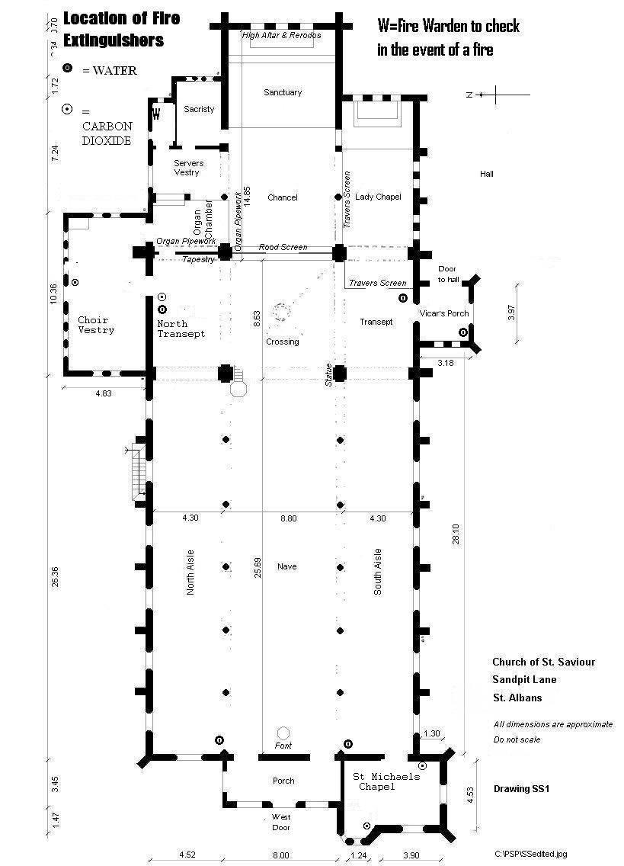

EXIT ROUTES

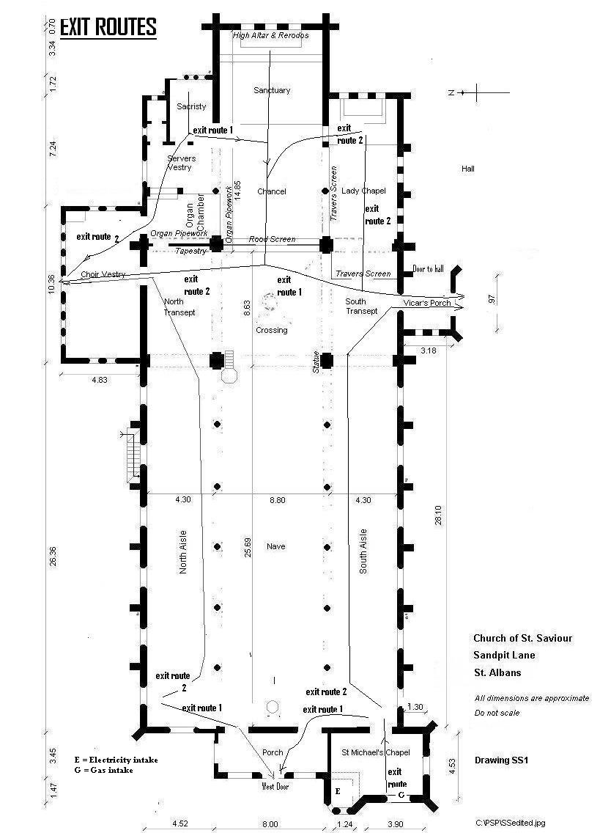

HALL EXIT ROUTES AND LOCATION OF FIRE EXTINGUISHERS

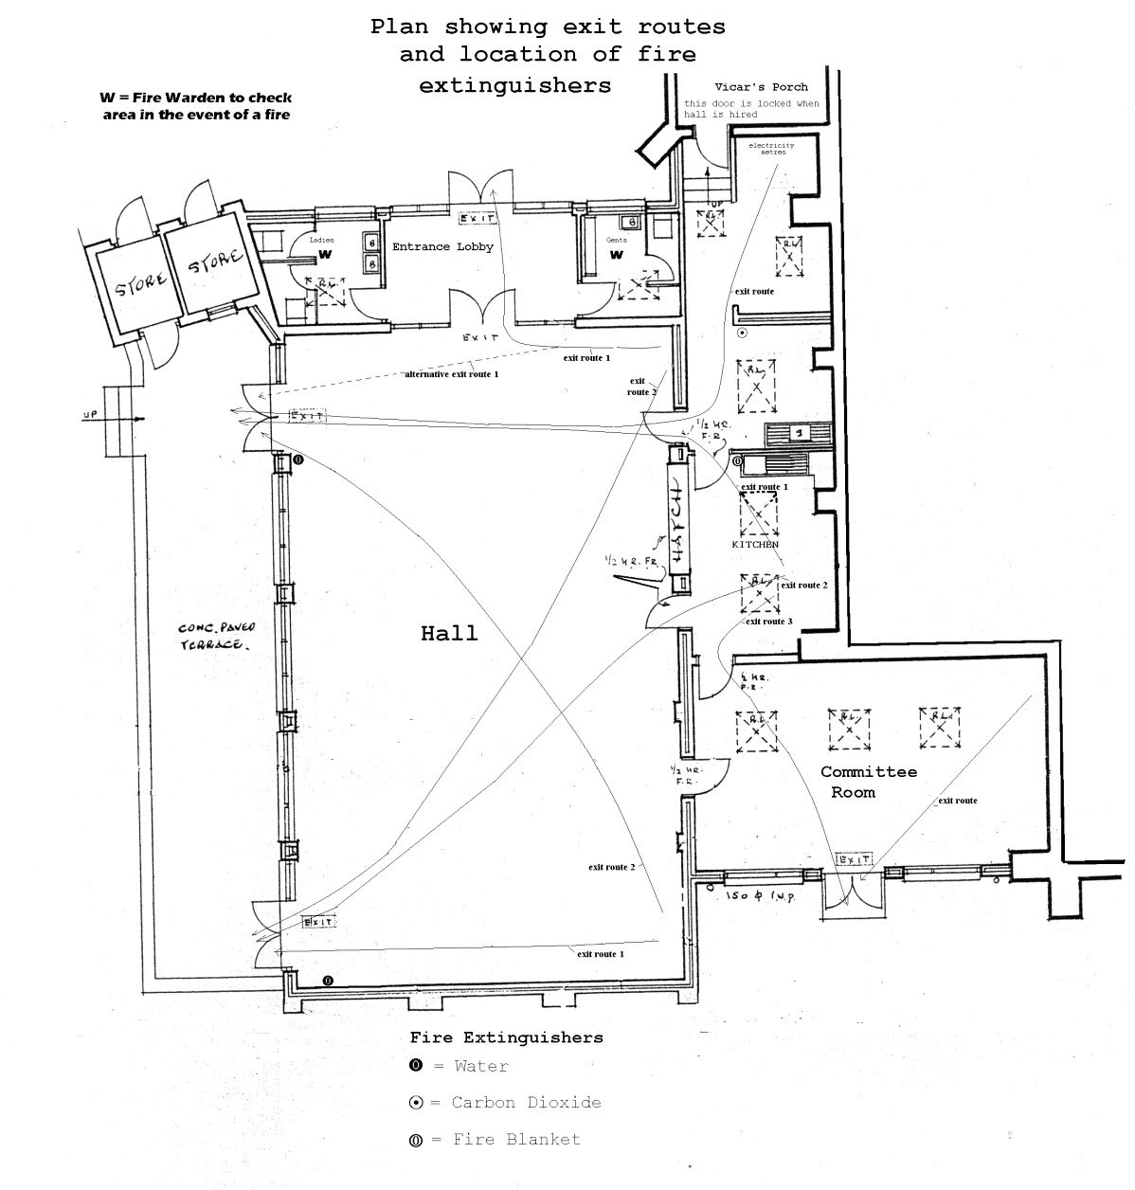

Annex 2: NOTES FOR THE REPLACEMENT OF FURNITURE
This information forms part of the Hire Agreement

GENERAL
  - Heavy equipment and instruments, staging etc. must be lifted. The floor must be protected from the spikes of cellos and double basses. The fabric of the church and hall must not be damaged or marked in any way.
  - Equipment, instruments and instrument cases must not be placed in any position which would create a hazard or would obstruct the escape routes for the Church or Hall.
  - Tape must not be used on the floors.
  - No electrical cables should be laid across the right-hand aisle, leading to the Hall. Cable covers are provided for the Hirer’s use.
  - If the church staging is used, it must be returned to the storage area as found, unless explicit arrangements otherwise have been made in writing.

Annex 3: PLANS FOR THE REPLACEMENT OF HALL FURNITURE

This information forms part of the Hire Agreement

GENERAL
- Please include sufficient time within the hire period to set up and clear away.
- Please turn off all heaters and lights when leaving the hall.
- Emergency exits are clearly labelled. Please do not obstruct them.

FURNITURE
- CHAIRS in the main hall (50 chairs)should be left stacked five high against the wall. Please ensure that any chairs stacked against the windows leave sufficient room for the curtains to be drawn behind them.
- SQUARE TABLES in the main hall should be left as indicated on the plan below.
- LONG TABLES should be stacked safely in the Lobby area; one long table
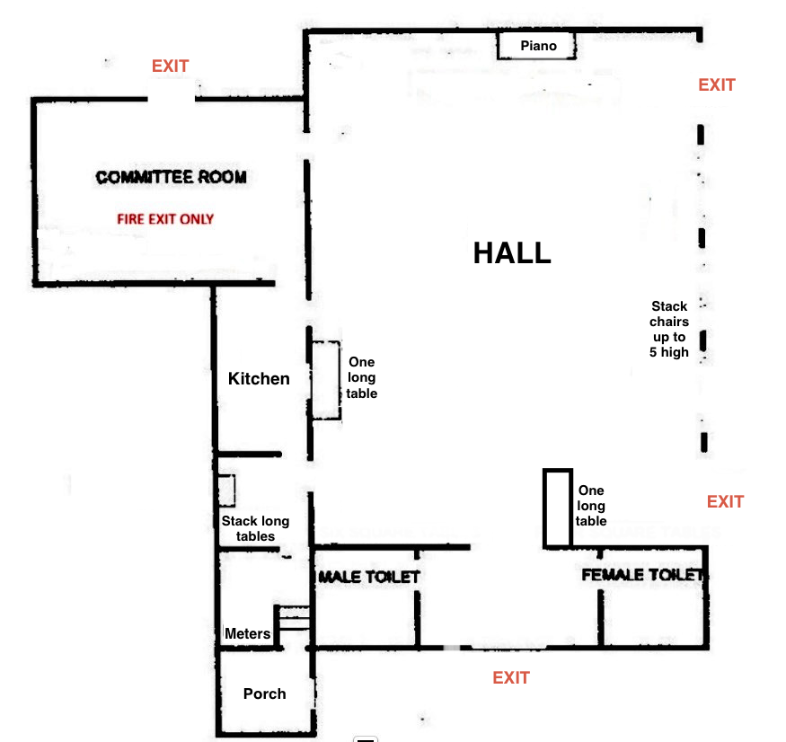
should be left under the servery hatch and a second by the door .

KITCHEN
- The Hirer is responsible for supplying rubbish bags for kitchen refuse.
- One rubbish bag may be left in the General waste bin by the Vicarage garage. The other (smaller) bin is for general recycling which is paper/ cardboard, tins and plastic
- We discourage use of single use cutlery and plates/ cups so are happy for you to use what is in the kitchen if it is washed and put away afterwards. We also encourage recycling.
- Please empty the urn after use.

CLEANING
- Buckets, mops, toilet rolls and vacuum cleaner can be found in the grey cupboard in the Lobby area. Brooms are stored beside the cupboard.
- Please wipe down all tables used.
- Please ensure that the floor is swept and kitchen floor is mopped.
- Please clean sink and taps, where used.
- Clean the stovetop, oven and microwave.
- , Check the toilets are clean and replace toilet rolls. Do not leave nappies in the bins.

BEFORE VACATING THE HALL
- Please empty the kitchen bin
- Double check that all lights and heaters have been turned off.
- Close all doors

